Invalid Username or Password:

Verify that the client is configured correctly.

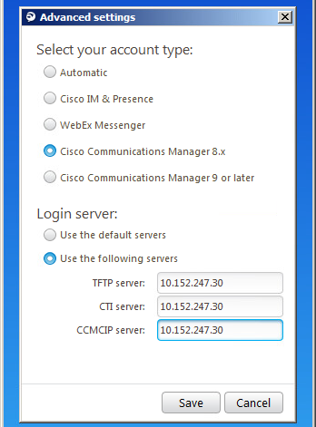

Also verify that they’re using the correct formatting of the username. Username will default to [user@contactusinc.com](mailto:user@contactusinc.com). The password is case sensitive with the first two letters capitalized and must be @ctus.cameohosted.com as below.

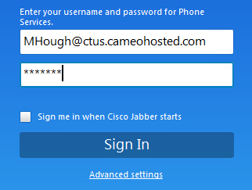

If any changes must be made to this page, you have to exit the client and relaunch it to save the settings. You must close the app from the menu to save:

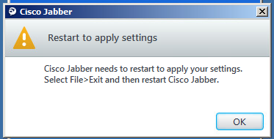

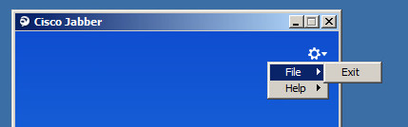

If the agent gets logged out of Finesse with this message or similar:

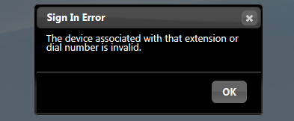

Their connection to the Jabber server has dropped. Click “OK” and then close the Finesse window. Then close the Jabber client. Use the File -> Exit menu option to close. If they’re stuck at a spinning wheel they’ve probably chosen File -> Sign Out. This will go on almost forever as there is no session to sign out of. If they have the spinning wheel close the app. At this point sign them back in to Jabber and then into Finesse. At this point they should be able to take calls. If they continue to have issues, verify the configuration as you would for a password issue.

When signing into Finesse now, they should no longer be using a 300xxxx number as the extension. In order to take calls they enter their username and password as they have before and their Jabber password for the extension.

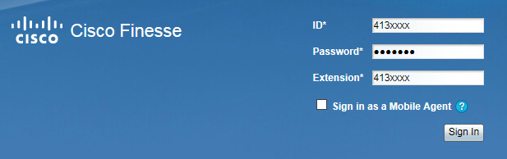

For most they will enter the same number into all 3 fields. However, there are a few agents that have different Jabber passwords than their Finesse ID. For these their ID and password will be the same but the extension will be different. sharrison and mpatterson are two agent that are configured this way.